Task 1: "How Do Big Systems Store Data?"

large-scale apps like Instagram, Uber, and Amazon use a mix of SQL and NoSQL databases, depending on their specific needs. Here's a breakdown:
1. Instagram (Meta)
Primary Database: PostgreSQL (SQL)
Used for core data like user profiles, posts, and comments.
Other Databases:
Cassandra (NoSQL) for scalability in handling large amounts of data (e.g., direct messages).
Redis for caching (e.g., feed updates, session storage).
2. Uber
Primary Early Database: PostgreSQL (SQL)
Initially used for trip data and user accounts.
Shift to NoSQL:
MySQL (SQL) for some relational data.
Schemaless (NoSQL, built on top of MySQL) for flexible data storage (e.g., ride details).
Redis for real-time matching and geolocation caching.
Elasticsearch for search and analytics.
3. Amazon
Primary Databases:
DynamoDB (NoSQL) for high-scale, low-latency needs (e.g., shopping cart, product catalog).
Aurora (SQL, MySQL/PostgreSQL-compatible) for relational data (e.g., orders, payments).
Redshift for data warehousing and analytics.
Why Do They Use Both SQL and NoSQL?
SQL (PostgreSQL, MySQL, Aurora) is used when:
Data has clear relationships (e.g., user accounts, transactions).
NoSQL (DynamoDB, Cassandra, Redis) is used when:
High scalability and low-latency reads/writes are needed (e.g., Uber’s ride-matching, Amazon’s product catalog).
The data model is flexible or schema-less (e.g., social media activity logs)

Try to find one that uses SQL Server specifically.
Company Using SQL Server: Stack Overflow
Primary Database: Microsoft SQL Server
High performance for read-heavy workloads (Q&A platform). Deep integration with .NET ecosystem (Stack Overflow is built on C#/ASP.NET). Enterprise-grade reliability & tooling (SSMS, AlwaysOn Availability Groups). Scale: Handles ~2 billion pageviews/month on SQL Server.

Task 2: "Do Video Games Use Databases?"
How do online games (like PUBG, Fortnite, etc.) store player progress, points, and profiles?
Video games often use databases to manage various types of data, including player information, game states, and in-game assets. These databases can be relational, such as MySQL or PostgreSQL, NoSQL databases like MongoDB, or even in-memory databases like Redis for fast, temporary storage.
In large-scale online games, databases are crucial for tracking player data, game states, and dynamic content. For example, player data includes account details, characters' stats, inventory items, and quest progress. Game state information, particularly in multiplayer games, involves the current status of the world, player locations, and in-game events.
Online games benefit from databases by allowing players to access their data from any device they play on, eliminating the need to transfer save files or remember unlock codes.

• Do they use SQL databases or something else?
Video games can use various types of databases, including SQL and NoSQL databases, depending on their specific requirements. SQL databases, such as MySQL or PostgreSQL, are often used for their robust querying capabilities and data integrity, especially in games with complex relational data, like MMORPGs with many players, items, and quests.
However, for real-time or large-scale multiplayer games where speed is crucial, or when dealing with unstructured data, NoSQL databases might be more suitable. Games typically use databases for backend processes, such as storing player statistics, high scores, and inventory data. They rarely use SQL databases in game clients due to the overhead and performance issues associated with SQL queries.

• Find an example of a game that uses a relational database.
World of Warcraft uses Oracle RDBMS to manage its data, storing information such as character locations and attributes in intervals and handling high priority data like level and item transfers in real-time.23. World of Warcraft: Uses Oracle RDBMS to manage game data, including character attributes and item transfers, demonstrating the use of relational databases in large-scale online games.

Task 3: Can a Database Work Without the Internet?
Search how databases are used in offline systems, like in military bases or airplanes.
Databases are used in offline systems in various ways, such as in military bases and airplanes, to ensure critical information is accessible even without an internet connection. For example, the Aircraft Characteristics Database, an official website of the United States government, provides essential aircraft data for aviation operations and maintenance.
These systems often rely on pre-downloaded data and local servers to function offline. This approach ensures that critical operations can continue even when there is no internet connectivity.

What kind of database do they use when no internet is available?
Databases are used in offline systems in various ways, such as in military bases and airplanes, to ensure critical information is accessible even without an internet connection. For example, the Aircraft Characteristics Database, an official website of the United States government, provides essential aircraft data for aviation operations and maintenance.
These systems often rely on pre-downloaded data and local servers to function offline. This approach ensures that critical operations can continue even when there is no internet connectivity. In military settings, databases like the Worldwide Casualty Reporting System (WCRS) and the Defense Medical Information System (DMIS) store and manage crucial information about military personnel and their health records.

Can SQL Server be used offline?
SQL Server databases are typically used in online systems where they can be accessed and managed through SQL Server Management Studio (SSMS) or other database management tools. However, in scenarios such as military bases or airplanes where internet connectivity might be limited or unavailable, databases are still used but in a different manner. In these environments, databases are often taken offline to perform maintenance tasks, backups, or schema changes without affecting the overall system's availability. When a database is taken offline, it is not accessible to users, and no transactions can be made on it.
To use SQL Server in environments with limited connectivity, the database can be taken offline for maintenance or schema changes, and then brought back online once the necessary tasks are completed. This process ensures that the database remains consistent and secure during periods of limited connectivity.

Task 4: "What Makes Online Stores So Fast?"

How do e-commerce platforms (like Amazon or Noon) organize their product and order data for fast searching?
Relational databases are widely used in cloud environments alongside other types of databases. Cloud providers offer managed services for relational databases, making them more accessible and easier to maintain compared to traditional on-premises setups. For example, Google Cloud offers Cloud SQL, Cloud Spanner, and AlloyDB, while Microsoft Azure provides Azure SQL Database and IBM Cloud Databases for PostgreSQL.235
Cloud databases can also include non-relational or NoSQL databases, which are designed to handle large volumes of unstructured or semi-structured data more flexibly than relational databases.47 However, relational databases remain popular for their structured approach and support for SQL, which allows for complex queries and transactions.35
In summary, cloud environments often use both relational and non-relational databases to cater to different data management needs.
• What challenges do they face in storing millions of products?
When storing millions of products, relational databases face several challenges. One of the main challenges is careful planning and design, as it requires identifying the entities, attributes, and relationships relevant to the online store and how they will be represented in the tables.1 Additionally, relational databases were originally designed for structured data and have a fixed schema, which can make it difficult to accommodate the unstructured or semi-structured data common in big data applications.5 This can be a challenge when dealing with millions of products, as the data may not fit neatly into a tabular structure. Another challenge is scalability, as managing large volumes of data and ensuring high availability and fault tolerance in distributed systems can be complex.

Task 5: "How Do Banks Protect Their Data?"

Search how banking systems use databases to protect sensitive customer data.
Banks use databases extensively to protect sensitive customer data by implementing various security measures. They create multiple copies of critical data, including banking transactions, using both synchronous and asynchronous methods. Some copies are written at the time of the transaction, while others are taken periodically, such as every hour, day, or week.
To secure these databases, banks employ multifactor authentication, encryption, privacy policies, and regular employee training.1 They also use sophisticated technology and monitoring techniques, intricate firewalls, and anomaly detection to safeguard customer data.1 Additionally, banks deploy data loss prevention (DLP) solutions like Endpoint Protector, which uses advanced Optical Character Recognition (OCR) technology to monitor and control how information is used, reducing the risk of insider threats and data loss.
Banks must also comply with data privacy and cybersecurity regulations, such as GDPR in Europe and GLBA in the United States, to protect customer information from unauthorized access and misuse.
What database features help with security and integrity?
Database security and integrity are maintained through several key features and practices. Authentication is a critical feature that verifies the identity of users accessing the database, ensuring that only authorized individuals can access it. This can include strong, multi-factor authentication methods such as biometric verification, one-time passwords (OTP), or hardware tokens.2
Access controls are another essential feature that restricts who can read, modify, or delete data within the database. These controls can be implemented through role-based access control (RBAC) or attribute-based access control (ABAC) strategies, which help in managing permissions effectively.24
Data validation and verification processes are crucial for maintaining data integrity. These processes ensure that the data entered into the database is accurate and consistent, preventing issues such as data duplication and unauthorized access to sensitive information.

• Find one bank or financial system that uses Oracle or SQL Server.
A large financial firm used both Oracle and SQL Server databases internally, with Oracle mostly for internal data collection and SQL Server for time-sensitive operations.2
Oracle Banking Platform: This is a core banking platform designed to help global retail banks transform and overhaul their legacy banking systems, indicating that Oracle is widely used in the banking sector
Task 6: "Draw Me the System!"
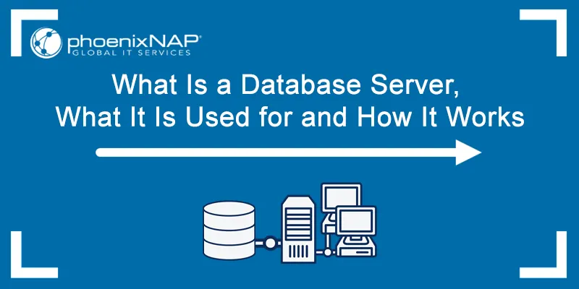
- Client Tier (Presentation Layer):
This is the user interface that users interact with directly
Examples: Web browsers, mobile apps, desktop applications
Responsibilities: Displays information, collects user input, handles presentation logic
Doesn't contain business logic - just presents data from the application tier
- Application Tier (Business Logic Layer):
The "brains" of the operation that processes requests
Handles business rules, data processing, and application logic
Acts as intermediary between client and database
Examples: Web servers (Apache, Nginx), application servers (Node.js, Tomcat)
Often contains APIs that the client tier calls
- Database Tier (Data Layer):
Responsible for data storage and retrieval
Manages data persistence and data integrity
Examples: MySQL, PostgreSQL, MongoDB, Oracle
Only accessible through the application tier (not directly by clients)
Game System Architecture
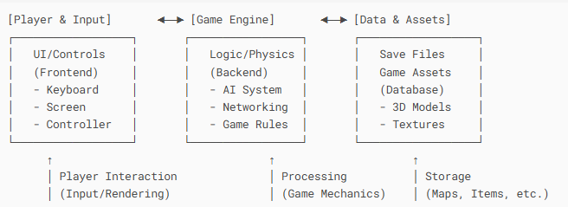

In a game's three-tier architecture, the Client Tier (frontend) handles player input and rendering, such as keyboard controls, UI, and graphics—this is what players directly interact with. The Application Tier (game engine) processes the core logic, including physics, AI, and multiplayer networking, acting as the system's brain. Finally, the Database Tier stores all game assets, such as 3D models, textures, and save files, ensuring data persistence without direct player access. This separation improves performance, scalability, and maintainability, allowing developers to update graphics (Client), tweak game mechanics (Application), or expand content (Database) independently. For example, when a player jumps, the input is captured by the Client, validated by the Engine, and animated using assets from the Database. This structure is fundamental in modern game development, from indie projects to AAA titles.

